Sex-Specific Predictors of 10-Year Incident Stroke in the Framingham Heart Study: A Cox Proportional Hazards Analysis
Introduction: This project uses data from the Framingham Heart Study, a longitudinal cohort designed to investigate cardiovascular disease risk factors. The objective is to identify baseline predictors of incident stroke within 10 years and to estimate predicted 10-year stroke risk for clinically relevant profiles. Analyses are stratified by sex and restricted to baseline (Period 1), with follow-up limited to 10 years. We hypothesize that older age, higher systolic blood pressure, and diabetes are strong predictors of stroke in both sexes. Additional cardiovascular risk factors, including smoking, cholesterol, body mass index, medication use, and prevalent coronary heart disease, are evaluated as potential predictors, with possible sex-specific differences. We also expect predicted stroke risk to increase across combinations of age, elevated blood pressure, and diabetes.
Methods: This study used data from the Framingham Heart Study, a longitudinal cohort designed to investigate cardiovascular disease risk factors. The dataset included 4,434 participants at the first examination, 3,930 at the second examination, and 3,263 at the third examination (Appendix, Figure S1), which illustrates the study population selection, exclusions, and analytic pipeline. For the primary analysis, we restricted the sample to baseline observations (Period 1). Of the 4,434 participants at baseline, 32 individuals with prevalent stroke (PREVSTRK = 1) were excluded to ensure that only incident stroke events were analyzed, resulting in a final analytic sample of 4,402 participants. All primary analyses were stratified by sex.
The primary outcome was incident stroke occurring within 10 years of baseline. Follow-up time was defined as the number of days from the baseline examination to the first stroke event or censoring and was administratively truncated at 10 years (3,650 days). A binary outcome variable (stroke10) was created to indicate whether a participant experienced a stroke within this time frame. Baseline covariates included age, systolic blood pressure, diabetes status, current smoking, antihypertensive medication use, total cholesterol, body mass index (BMI), and prevalent coronary heart disease. These variables were selected based on prior literature and treated as fixed exposures measured at baseline.
Baseline characteristics were summarized by sex using means and standard deviations (SDs) for continuous variables and frequencies and percentages for categorical variables. Kaplan–Meier methods were used to estimate stroke-free survival over 10 years separately for men and women using the complete-case sample.
Primary analyses were conducted using sex-specific Cox proportional hazards models to evaluate associations between baseline risk factors and incident stroke within 10 years. Initial models included all candidate covariates, and backward selection was performed with a stay criterion of p < 0.10.
Age, systolic blood pressure, and diabetes were prespecified and retained in all models regardless of statistical significance due to their clinical importance. Hazard ratios (HRs) and 95% confidence intervals (CIs) were reported, with age and systolic blood pressure modeled as continuous variables; additional hazard ratios for 10-unit increases were examined for interpretability. Proportional hazard assumptions were tested using Supremum test based on cumulative sum of martingale residuals.
Analyses were conducted using a complete-case approach. A total of 127 participants (33 men and 94 women) were excluded due to missing covariate data, resulting in a final analytic sample of 4,275 participants. Because missingness was low (<3%), a complete-case approach was used; however, potential bias due to non-random missingness was considered. Predicted 10-year stroke probabilities were estimated from the final Cox models using baseline survival functions and evaluated at 10 years (3,650 days) for illustrative risk profiles defined by combinations of age (40, 50, and 60 years), systolic blood pressure (120 vs. 160 mmHg), diabetes status, and smoking status (men only).
Finally, descriptive analyses using examination periods 1 through 3 were conducted to assess temporal changes in key risk factors. Mean systolic blood pressure and the prevalence of diabetes and smoking were calculated by sex and examination period. All analyses were conducted using SAS OnDemand for Academics.
Results: Baseline characteristics stratified by sex are presented in Table 1 using the full baseline sample (N = 4,402). Mean follow-up time was similar between men and women (9.39 vs. 9.59 years), and the 10-year incidence of stroke was low and comparable (2.54% in men vs. 2.51% in women). During the 10-year follow-up, 413 participants (9.4%) died and were treated as censored observations, with higher mortality among men (12.0%) than women (7.36%). Mean age was similar between sexes. Women had slightly higher systolic blood pressure and total cholesterol, whereas men had higher BMI and a greater prevalence of coronary heart disease. Diabetes prevalence was similar between sexes, while smoking was substantially more common among men.
Kaplan–Meier estimates of stroke-free survival over 10 years remained high for both men and women (Appendix, Figures S2–S3), indicating a low cumulative incidence of stroke over the follow-up period. Among men, this corresponded to a cumulative incidence of 2.7%, while women showed a similar pattern (2.5%).
In Cox models (Table 2), age and systolic blood pressure were significant predictors of stroke in both sexes. Among men, diabetes (HR = 4.81, 95% CI: 2.10–11.01) and current smoking (HR = 1.92, 95% CI: 1.04–3.57) were also associated with increased risk. Among women, diabetes was retained but not statistically significant, and smoking was not retained. For interpretability, hazard ratios were examined per 10-unit increase. Among men, a 10-year increase in age was associated with a 90% higher stroke risk (HR = 1.90, 95% CI: 1.31–2.76), and a 10 mmHg increase in systolic blood pressure with a 40% higher risk (HR = 1.40, 95% CI: 1.25–1.56). Among women, a 10-year increase in age was associated with a twofold increase in risk (HR = 2.03, 95% CI: 1.38–2.99), while a 10 mmHg increase in systolic blood pressure was associated with a 29% higher risk (HR = 1.29, 95% CI: 1.19–1.40).
Assessment of the proportional hazard assumption indicated no evidence of violation based on supremum tests (Appendix, Table S1). However, graphical diagnostics (Appendix, Figures S4–S10) suggested a potential deviation for diabetes in men. In contrast, plots for other covariates showed random fluctuation around zero, supporting the proportional hazards assumption.
Predicted 10-year stroke risk increased with age across all profiles (Figure 1, Table S2), with the highest risk observed among individuals with both elevated systolic blood pressure and diabetes. At age 60, this profile corresponded to a predicted risk of 22.3% in men versus 9.4% in women. Men consistently exhibited higher predicted risks than women.
Descriptive analyses demonstrated that systolic blood pressure increased over time in both sexes, rising from 131.7 to 139.3 mmHg in men and from 133.8 to 140.9 mmHg in women across examination periods 1 to 3 (Figure 2). Similarly, the prevalence of diabetes increased over time, from 3.0% to 8.7% in men and from 2.5% to 7.1% in women. In contrast, smoking prevalence declined substantially, particularly among men, decreasing from 60.4% to 38.9%, while in women it decreased from 40.4% to 31.0%.
Conclusions/Discussion:
This study identified key baseline predictors of 10-year incident stroke in the Framingham cohort using sex-stratified analyses restricted to the first 10 years of follow-up. Age and systolic blood pressure were strong predictors in both sexes, while diabetes and smoking were additionally associated with increased risk among men but not women, possibly reflecting limited power or biological differences. Predicted stroke risk increased with age and was highest among individuals with both elevated systolic blood pressure and diabetes. Men consistently exhibited higher predicted risks than women despite similar crude incidence, suggesting stronger associations between risk factors and stroke in men.
Although the proportional hazards assumption was not formally violated for diabetes in men, graphical diagnostics suggested potential nonproportionality. This may reflect limited power or time-varying effects, particularly given increasing diabetes prevalence over time. Because diabetes was modeled as a baseline exposure, these temporal changes are not captured.
Consistent with this, descriptive analyses across the three examination periods showed that systolic blood pressure and diabetes prevalence increased over time, while smoking declined, indicating that risk factors change within individuals. Because the primary analysis used only baseline covariates, these changes are not reflected in the model and may lead to exposure misclassification. As a result, time-varying covariate models may yield different effect estimates. For example, individuals who develop diabetes or experience increases in blood pressure during follow-up would be reclassified, potentially strengthening associations or altering statistical significance. Thus, time-varying approaches may provide more accurate estimates of stroke risk.
Several limitations should be considered. Complete-case analysis, although missingness was low (<3%), may introduce bias if data are not missing completely at random. The predominantly White Framingham cohort may limit generalizability. The analysis relied on baseline covariates which may lead to exposure misclassification. Stroke outcomes were limited to clinically apparent events without subtype differentiation, and changes in diagnostic practices may have introduced misclassification. Finally, deaths from all causes were treated as censored and competing risks were not explicitly modeled, which may overestimate stroke risk.
In conclusion, age and systolic blood pressure are the strongest predictors of stroke risk, with additional contributions from diabetes and smoking, particularly in men. While baseline models provide useful estimates, incorporating time-varying covariates in future analyses may improve risk estimation.

Table 1. Baseline Characteristics and 10-Year Outcomes of Study Participants by Sex at Examination 1
Characteristic | Men (n = 1930) | Women (n = 2472)
Follow up time, mean (SD) | 9.39 (1.82) | 9.59 (1.54)
10-year Stroke, n (%) | 49 (2.54) | 62 (2.51)
10- year All-cause Mortality, n (%) | 231 (12.0) | 182 (7.36)
Age, mean (SD), years | 49.73 (8.71) | 49.99 (8.63)
Systolic BP, mean (SD), mmHg | 131.60 (19.40) | 133.66 (24.33)
Total Cholesterol, mean (SD), mg/dL | 233.62 (42.39) | 239.70 (46.19)
BMI, mean (SD), kg/m² | 26.17 (3.40) | 25.57 (4.52)
Diabetes, n (%) | 59 (3.06) | 60 (2.43)
Prevalent CHD, n (%) | 120 (6.22) | 67 (2.71)
Current Smoker, n (%) | 1168 (60.52) | 1001 (40.49)
BP Medication Use, n (%) | 40 (2.10) | 96 (3.94)

Abbreviations: SD, standard deviation; BMI, body mass index; CHD, coronary heart disease; BP, blood pressure.
Notes: Table reflects baseline sample (N = 4,402); subsequent survival analyses use the complete-case sample (N = 4,275). Values are presented as mean (SD) for continuous variables and number (percentage) for categorical variables. Percentages are column percentages calculated within sex. Missing data were minimal (<3%) for all variables.

Table 2. Sex-Specific Cox Proportional Hazards Models for 10-Year Incident Stroke in the Framingham Heart Study (Complete-Case Analysis, N = 4,275)

Variable | Men HR  (95% CI) | p-value | Women HR  (95% CI) | p-value
Age (years) | 1.07 (1.03–1.11) | 0.0008 | 1.07 (1.03–1.12) | 0.0003
Systolic BP (mmHg) | 1.03 (1.02–1.05) | <0.0001 | 1.03 (1.02–1.03) | <0.0001
Diabetes (Yes) | 4.81 (2.10–11.01) | 0.0002 | 1.77 (0.64–4.90) | 0.27
Current Smoker (Yes) | 1.92 (1.04–3.57) | 0.038 | — | —

Abbreviations: BP, blood pressure, HR, hazard ratio; CI, confidence interval
Notes: Hazard ratios are reported per 1-unit increase for continuous variables; additional hazard ratios per 10-unit increase are presented in the text for interpretability. Variables not retained after backward selection are not shown.

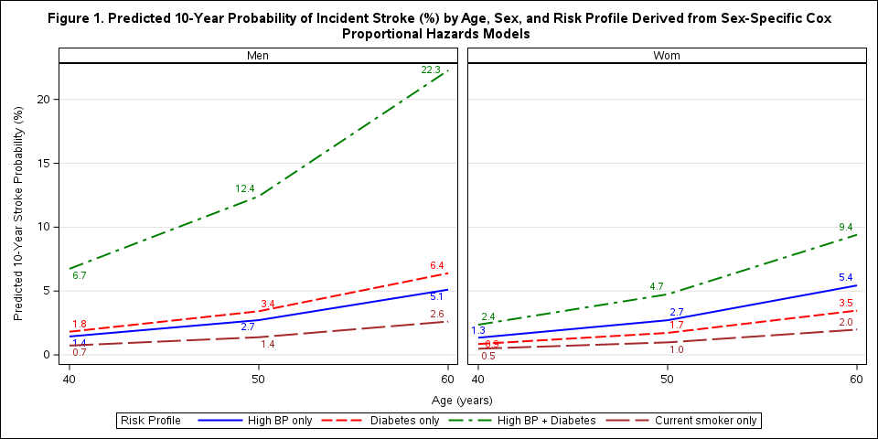
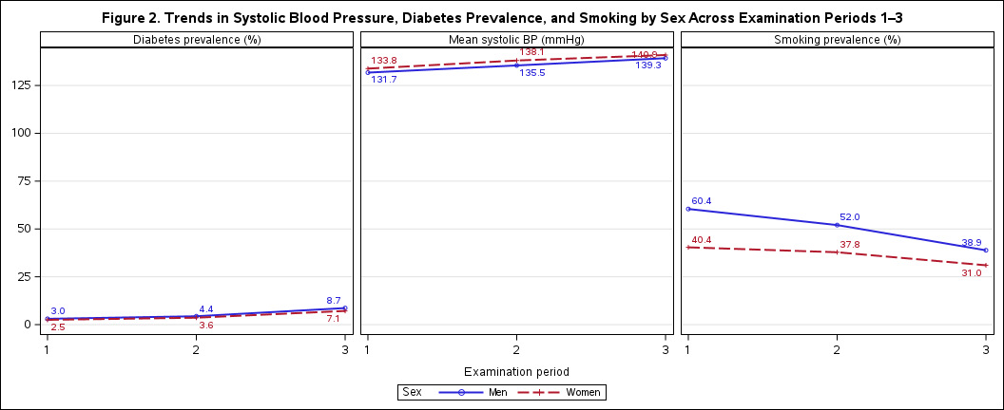

Raw Data
The original raw data were obtained from the BIOS6624 Canvas site under the P3 module. Both the raw and processed datasets used to produce these results are stored locally on my computer at:
C:\Users\mojde\Desktop\Documents\BIOS-6624-Projects\Project3\DataRaw
R code
https://github.com/mojdemir/BIOS-6624-Projects/tree/main/Project3/Code

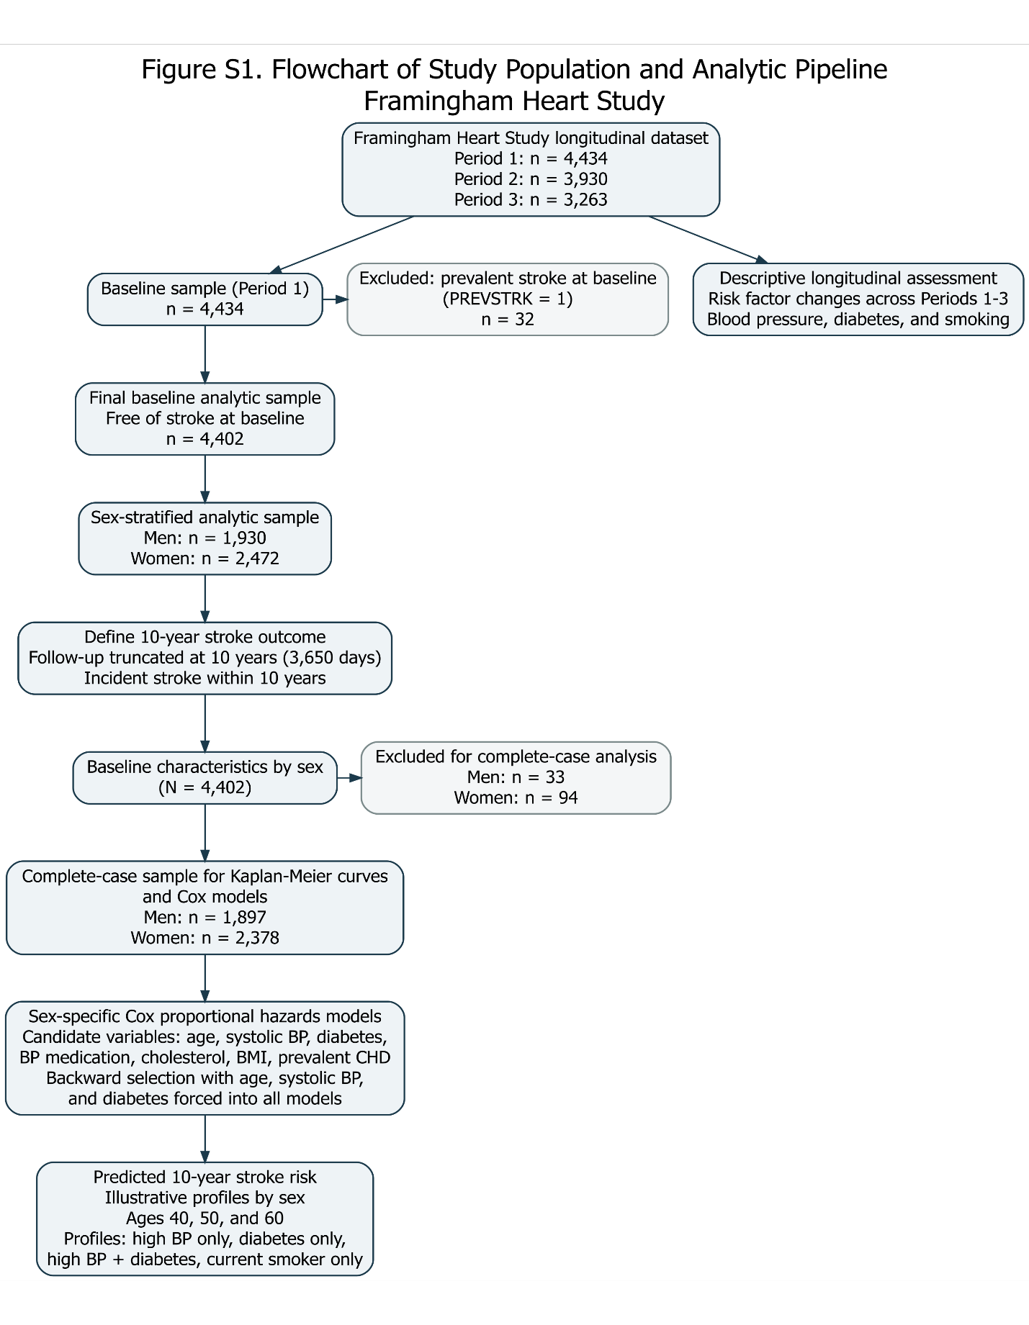
Appendix

Figure S2. Kaplan–Meier Curve for 10-Year Stroke-Free Survival in Men
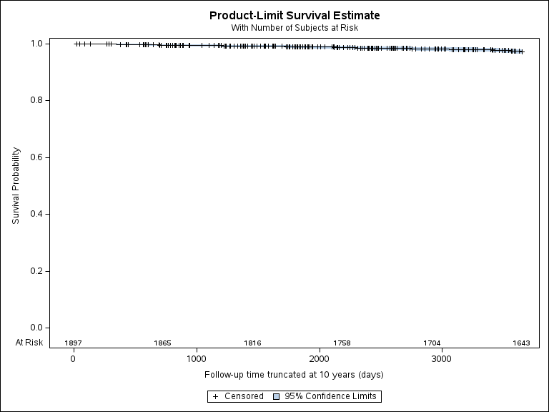

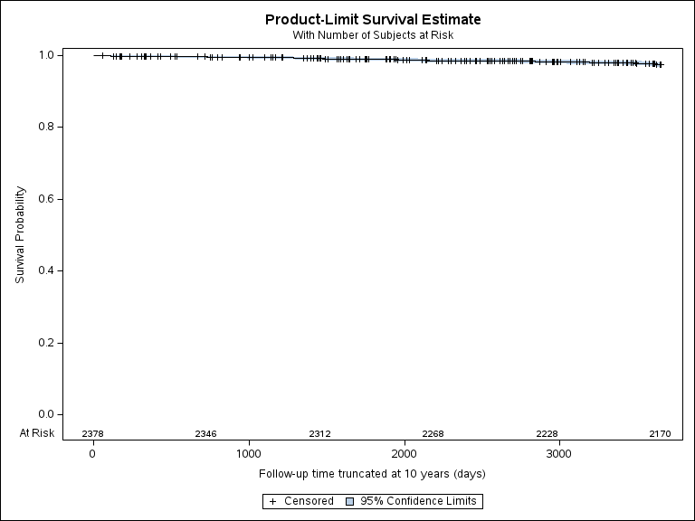
Figure S3. Kaplan–Meier Curve for 10-Year Stroke-Free Survival in Women

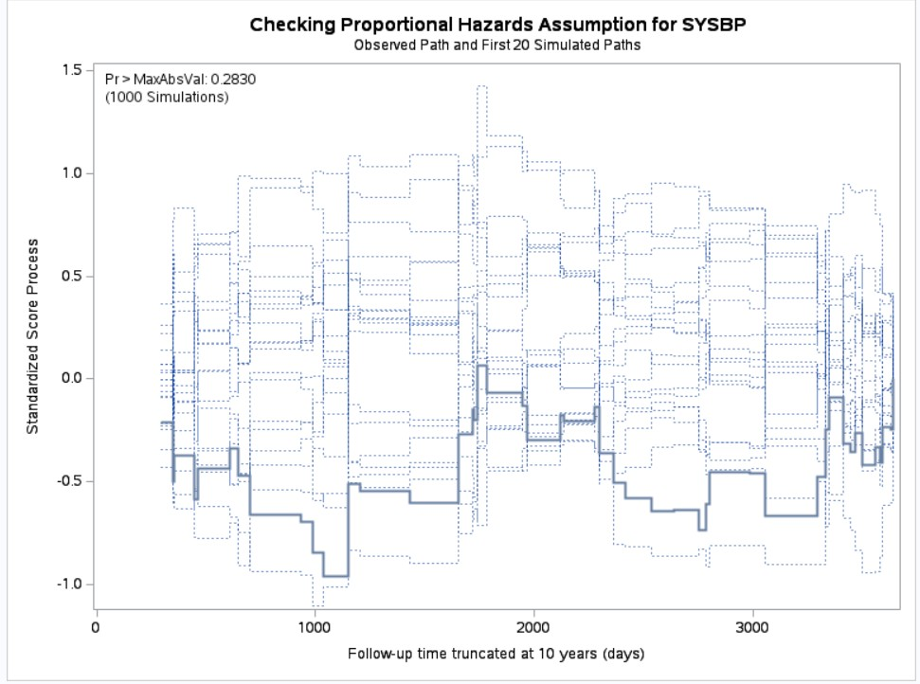
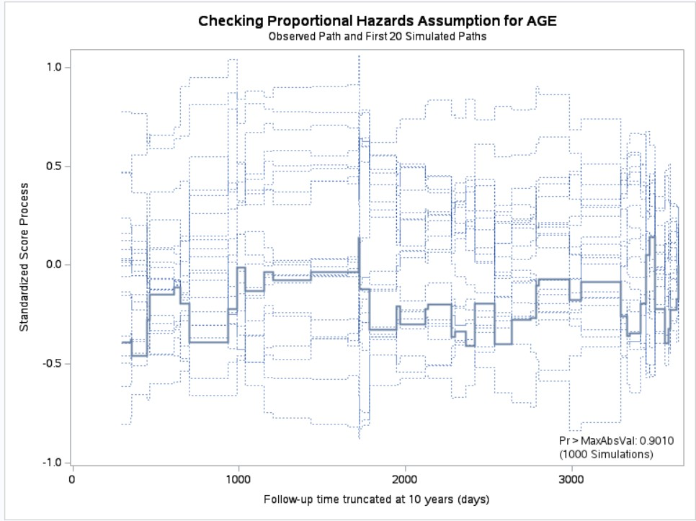
Figures S4–S7. Assessment of the Proportional Hazards Assumption in Men Using Standardized Score Process Plots

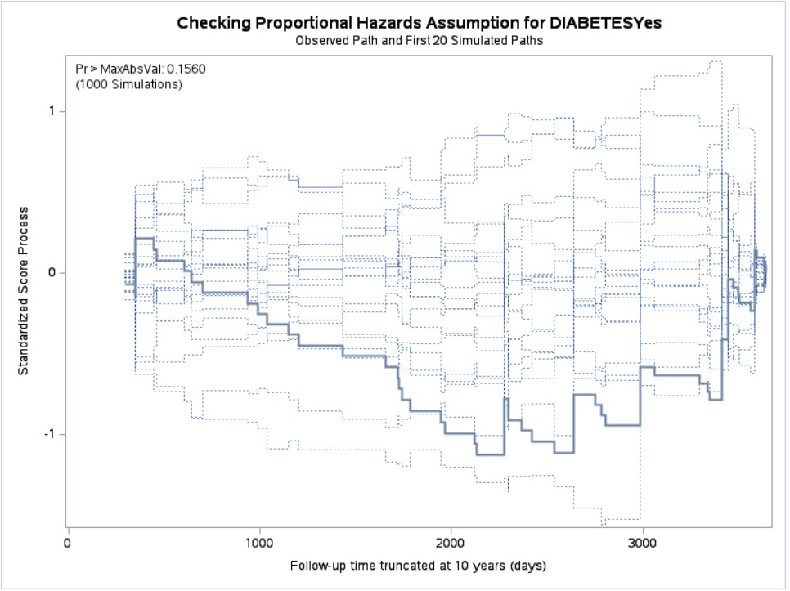
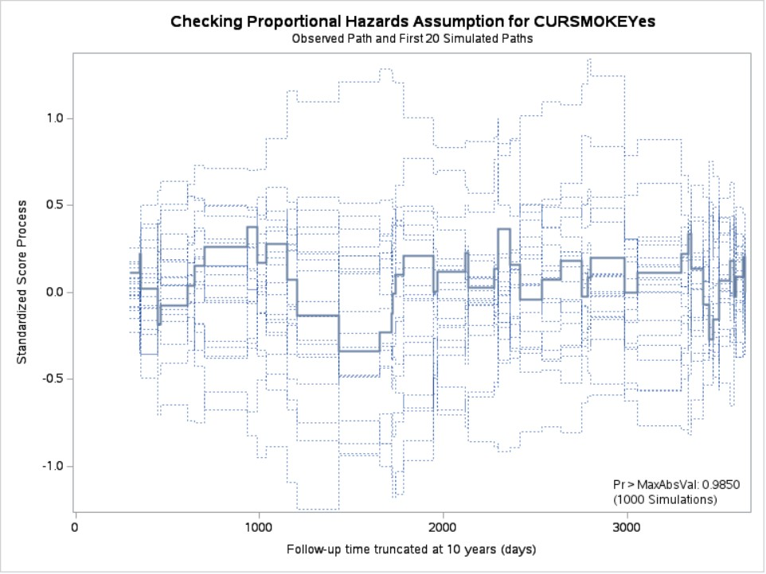

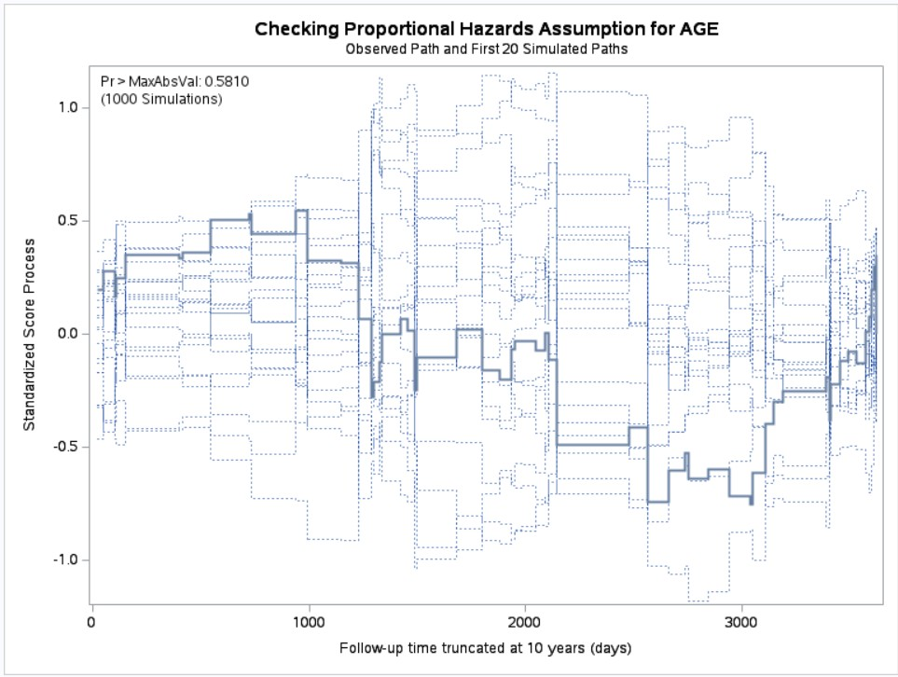
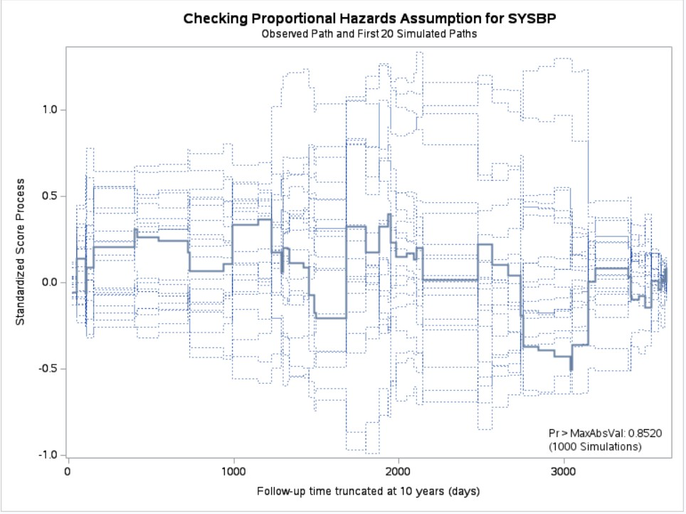
Figures S8–S10. Assessment of the Proportional Hazards Assumption in Women Using Standardized Score Process Plots

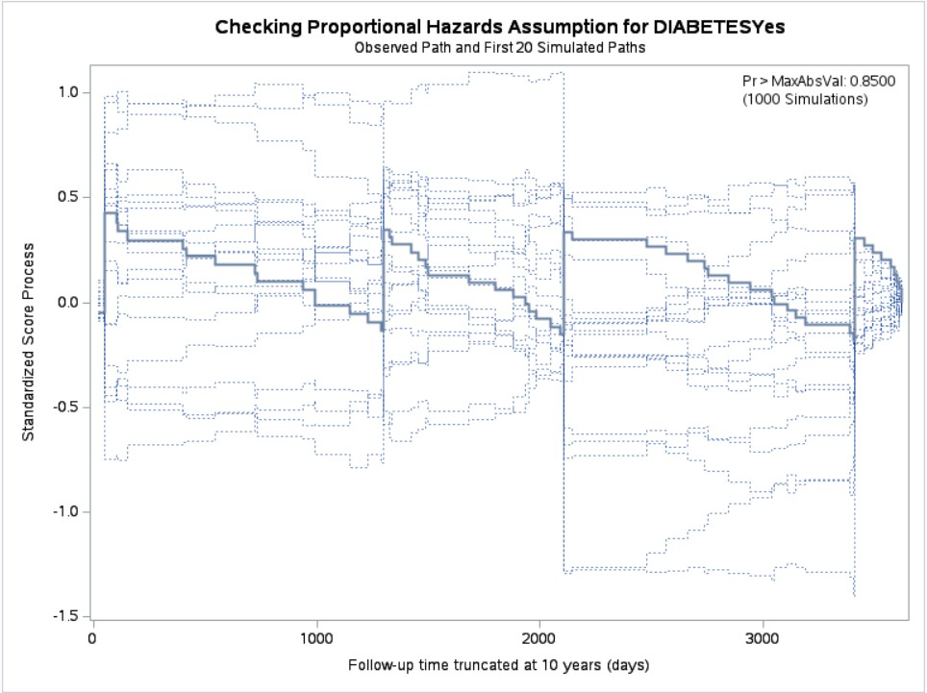

Table S1. Assessment of the Proportional Hazards Assumption Using Supremum Tests for Sex-Specific Cox Models

Variable | Men p-value | Women p-value
Age | 0.458 | 0.753
Systolic BP | 0.958 | 0.507
Diabetes (Yes) | 0.127 | 0.427
Current Smoker (Yes) | 0.374 | -

Abbreviations: BP, blood pressure.
Notes: Smoking was not retained in the final model for women; predicted values for smoking in women are shown for descriptive comparison only. P-values are based on supremum tests assessing the proportional hazards assumption for each covariate. A p-value < 0.05 indicates evidence of violation of the proportional hazards assumption.

Table S2. Predicted 10-Year Probability of Incident Stroke (%) by Age, Sex, and Risk Profile Derived from Sex-Specific Cox Models in the Framingham Heart Study (Complete-Case Sample)
Age (years) | Sex | High BP only | Diabetes only | High BP + Diabetes | Current smoker only
40 | Women | 1.34 | 0.85 | 2.36 | 0.48
 | Men | 1.44 | 1.81 | 6.74 | 0.73
50 | Women | 2.71 | 1.72 | 4.74 | 0.98
 | Men | 2.72 | 3.42 | 12.42 | 1.38
60 | Women | 5.44 | 3.47 | 9.40 | 1.98
 | Men | 5.11 | 6.39 | 22.27 | 2.61

Abbreviations: BP, blood pressure.
Notes: Predicted probabilities were estimated from sex-specific Cox proportional hazards models at 10 years (3,650 days). High BP defined as systolic blood pressure = 160 mmHg; reference level = 120 mmHg. Diabetes and smoking are defined as present versus absent.

